Table of Contents

Document Version 2

1. Purpose 3

1.1. Intended Audience 3

1.2. Intended Use 3

1.3. Scope 3

1.4. Definitions and Acronyms 3

2. Overall System Description 4

2.1. Use Case Diagrams 4

2.2. System Architecture 5

2.3. Functional Requirements 6

2.3.1. Sensor Deployment and Monitoring 6

2.3.2. Automated Fire Alert 6

2.3.3. Manuel Emergency Alert 6

2.3.4. Fire Suppression using Sprinklers 6

2.3.5. Multi-Modal Alert System 7

2.3.6. Mobile App & Remote Monitoring 7

2.3.7. AI-Powered Fire Risk Prediction 7

2.4. Non-Functional Requirements 8

2.4.1. System Qualities & Constraints 8

3. Software Architecture 9

3.1. Static Software Architecture 9

# Document Version

|  |  |  |  |  |
| --- | --- | --- | --- | --- |
| No | Update | Name | Date | Version |
| 1. | Initial version | Meena | 11/6/2025 | 1.0 |

# Purpose

## Intended Audience

This SRS document describes the System Requirements and Software Design for an IoT-based Smart Fire Alert System and the target audience are **System Designers, Embedded Engineers, SCDF Tech Division, and Emergency System Developers** working on the development of this project.

## Intended Use

The SRS defines the overall System Architecture and Requirements as well as the Software Architecture and Design. This document also contains the definition of the System Requirements which shall be used as the input for System Test cases and Software Unit Test cases.

## Scope

The Smart Fire Alert System is designed for deployment in rental apartments of elderly residents in Singapore. It aims to provide early detection and notification of fire events using multiple sensor modalities, automated sprinkler activation, and multi-channel alert systems

## Definitions and Acronyms

|  |  |
| --- | --- |
| **Acronym** | **Description** |
| IR | Infra Red |
| LED | Light Emitting Diode |
| NFC | Near Field Communication |
| SW | Software |
| HW | Hardware |
| SCDF | Singapore Civil Defence Force |
| IoT | Internet of Things |
| SMS | Short Message Services |
| LCD | Liquid Crystal Display |

# Overall System Description

## Use Case Diagrams

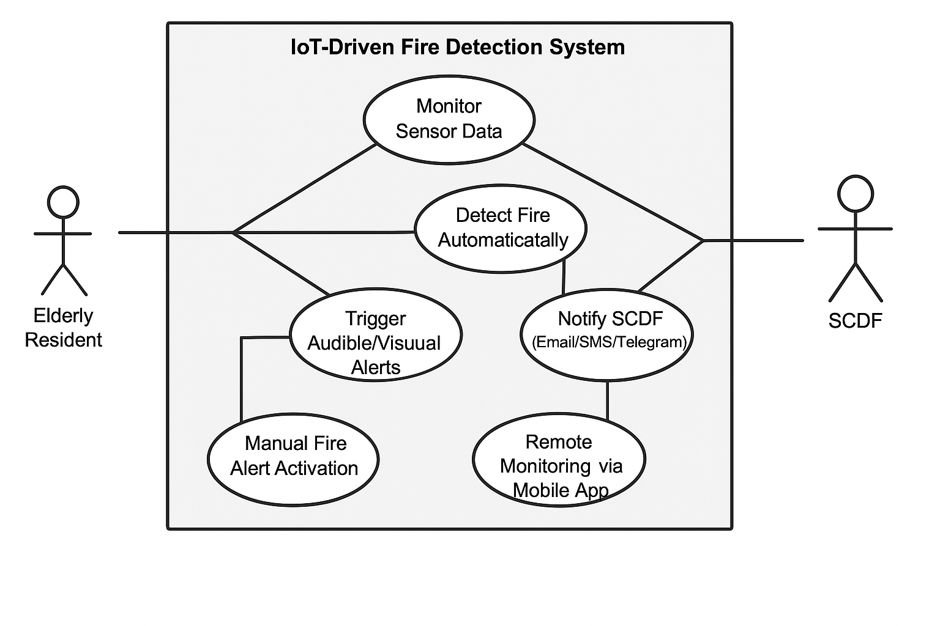

## System Architecture

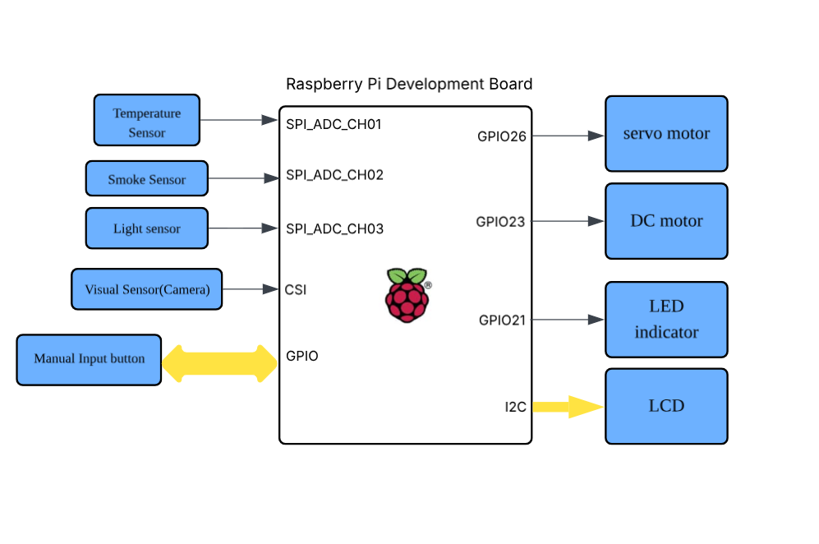

## Functional Requirements

### Sensor Deployment and Monitoring

The system continuously monitors the condition of the room using multiple types of sensors to detect early signs of a fire.

|  |  |
| --- | --- |
| **REQ_ID** | **Requirement** |
| REQ-01 | The system shall deploy these sensors: Temperature Sensors, Visual Sensors, Light Sensors, and Smoke Detectors. |
| REQ-02 | The system shall ensure that all deployed sensors are always active and operational during system runtime. |
| REQ-03 | The system shall perform health check on all sensors at a predefined regular interval which is every 5 seconds. |
| REQ-04 | If any sensor is found to be faulty or fails to update its status, the system shall automatically notify the maintenance office while displaying the non-operational sensor status on an LED indicator to alert people about the system. |
| REQ-05 | The system shall continuously collect and analyse data from all installed sensors to monitor for indications of a fire. |
| REQ-06 | Each sensor shall detect fire conditions based on specific parameters, such as a rise in temperature, visual flame detection, the presence of smoke, or a sudden increase in light intensity. |

### Automated Fire Alert

When fire is detected by any of the 4 sensors, the system will trigger an alert to residents & sends a notification to SCDF.

|  |  |
| --- | --- |
| **REQ_ID** | **Requirement** |
| REQ-07 | If any sensor detects a potential fire outbreak, the system shall activate an alarm in the household to alert the residents. |
| REQ-08 | Upon detecting a fire, the system shall notify the Singapore Civil Defence Force (SCDF) through email, SMS, Telegram, or other available communication methods. |

### Manuel Emergency Alert

In case of emergencies, residents should be able to manually alert SCDF or urgent help, if required.

|  |  |
| --- | --- |
| **REQ_ID** | **Requirement** |
| REQ-06 | The system shall include a manual switch or button that residents can activate when needed, which will immediately send an alert to the SCDF. |

### Fire Suppression using Sprinklers

The system activates the sprinkler system in the affected room as the first line of defense.

|  |  |
| --- | --- |
| **REQ_ID** | **Requirement** |
| REQ-07 | When fire is detected, the system shall activate the sprinkler system in the affected room. |
| REQ-08 | The sprinkler system shall be electrically connected to a control valve, which is operated by a servo motor, DC motor, or a digital output via relay. |

### Multi-Modal Alert System

When fire is detected through one of the sensors, other types of alerts such as visual, verbal alerts should be activated for residents with disabilities.

|  |  |
| --- | --- |
| **REQ_ID** | **Requirement** |
| REQ-09 | The system shall provide visual alerts, such as notifications displayed on an LCD, to accommodate hearing-impaired residents. |
| REQ-10 | The system shall send real-time fire alerts through mobile app push notifications, in addition to SMS and email notifications. |
| REQ-11 | The system shall include verbal announcements that specify the exact room where the fire was detected. |
| REQ-12 | The system shall turn on all the lights in the apartment upon detecting a fire. |

### 

### Mobile App & Remote Monitoring

The system provides a mobile interface for residents, and authorised users (e.g. caregivers) to monitor sensor data, receive alerts, and remotely manage emergency responses in real time.

|  |  |
| --- | --- |
| **REQ_ID** | **Requirement** |
| REQ-13 | The system shall be integrated with a mobile application that displays real-time sensor data and alert history. |
| REQ-14 | The app shall allow users to remotely acknowledge alerts and manually activate the sprinkler system |
| REQ-15 | Authorised users shall receive alerts and updates remotely via the mobile application. |

### AI-Powered Fire Risk Prediction

The system incorporates intelligent analysis using AI or machine learning algorithms to identify early risk patterns and provide proactive alerts before a fire fully develops.

|  |  |
| --- | --- |
| **REQ_ID** | **Requirement** |
| REQ-16 | The system shall use AI / Machine Learning algorithms to analyse sensor trends and predict potential fire risks. |
| REQ-17 | The system shall send early warnings when abnormal patterns, such as sustained high temperatures, are detected before a fire starts. |

## Non-Functional Requirements

### System Qualities & Constraints

These requirements should define the performance of the system, the usability, maintainability and other operational expectations.

|  |  |
| --- | --- |
| **REQ_ID** | **Requirement** |
| REQ- | The system shall detect fire events with minimal false positives and false negatives. |
| REQ- | The system shall optimise power usage by operating sensors and modules in low-power mode when system is idle. |
| REQ- | The system shall operate in real-time, responding to fire detection events within 5 seconds. |
| REQ- | The system interface (including manual switch / button), shall be easily usable by elderly residents with minimal training on the usage. |
| REQ- | The system design shall support deployment in multiple households across Singapore without major reconfigurations. |
| REQ- | The system shall allow maintenance staffs to easily replace or calibrate individual sensors. |
| REQ- | The system shall support integration with third-party messaging platforms (e.g. Email Server, SMS Gateway, Telegram API etc.) |
| REQ- | The system shall be operational 24/7, with a minimum system uptime of 99.5%. |

# Software Architecture

## Static Software Architecture

The Software Architecture defines the various Software Components that are developed to realize the implementation of the system requirements.

**WiFi**

**HMI**

**PowerMgt**

**Application Layer**

**Hardware Abstraction Layer (HAL)**

**LED**

**Buzzer**

**TempSensor**

**SmokeSensor**

**GSM**

**FireDetection**

**AlertMgt**

**Battery**

**Application Layer**

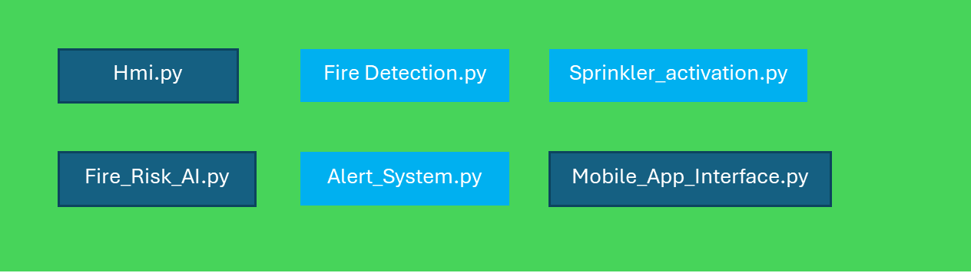

**Hardware Abstraction Layer**

